**Question 3**

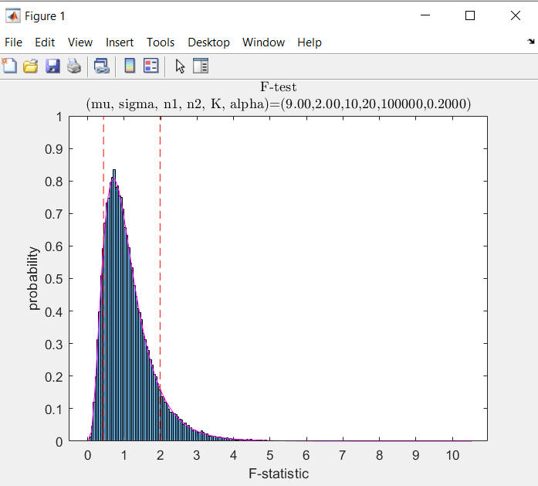

**Question 4**

(b)

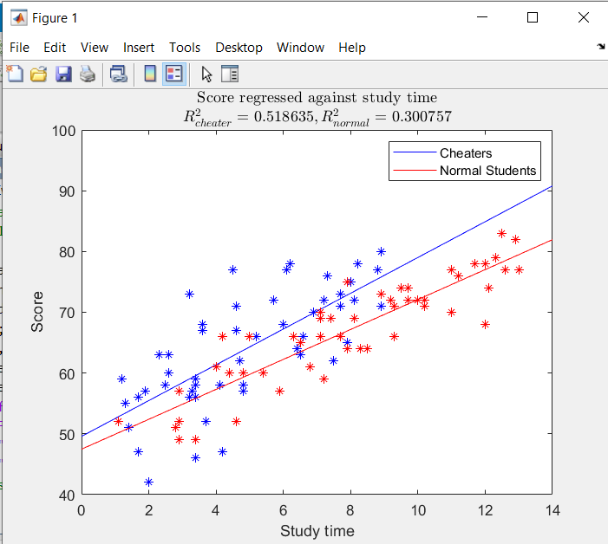

(c) The p-value in (a) is 0.0837, and since we are using a significance level of 0.05, that means we reject the null hypothesis and conclude that the papers should have helped the students. In (b), we see that the fitted line of cheaters’ scores is higher than those of normal students. We may conclude that with the same study time, cheaters tend to score higher than non-cheaters. Overall, we conclude that the past papers do help the student achieve a higher score.

**Question 5**

$$A\left[0\right]=B\left[0\right]=0$$

$$F=F_{in}=F_{out}$$

$$r_{B1}=k_{1}\left[A\right]$$

$$r_{B2}=k_{2}{\left[A\right]}^{2}$$

Set ${\left[A\right]}_{in}=1,\frac{F}{V}=1$.

Mole balance

$$\frac{d[A]}{dt}V=F_{in}{\left[A\right]}_{in}-r_{B1}V-r_{B2}V-F_{out}\left[A\right]$$

$$\frac{d\left[B\right]}{dt}V=r_{B1}V+r_{B2}V-F_{out}\left[B\right]$$

$$\frac{d\left[A\right]}{dt}=\frac{F}{V}{\left[A\right]}_{in}-k_{1}\left[A\right]-k_{2}{\left[A\right]}^{2}-\frac{F}{V}[A]$$

$$\frac{d\left[B\right]}{dt}=k_{1}\left[A\right]+k_{2}{\left[A\right]}^{2}-\frac{F}{V}\left[B\right]$$

For the code, please refer to the files

fitReactionTank.m

reactionTank1.m

reactionTank2.m

1. $R_{1}^{2}= 0.985145, R_{2}^{2}= 0.980752$. Since the coefficient of determination of model 1 is greater, it seems that model 1 fits the data better.
2. $R_{1\left(k=1\right)}^{2}=0.985145,R_{1\left(k=1.2\right)}^{2}=0.973221,R_{2\left(k=1\right)}^{2}=0.980752,R_{2\left(k=1.2\right)}^{2}=0.994235$. Since overall, the coefficient of determination of model 2 is greater than that of model 1, we may say that model 2 may fit the data better overall. Although the differences in R2 in the case of k=1.2 is much greater, it does not make us more confident because the k=1 gives a different conclusion. Our conclusion may need to be supported by more data.

